|  |
| --- |
| *CometBites* |
| **Feasibility Analysis** |
| **SE 6387 Advanced Software Engineering Project**  **R.Z. Wenkstern**    ***9/7/2016*** |

|  |
| --- |
| **Group *CometBites*** |
| **Ronaldo Goncalves Junior**  **rxp152830** |
| **Twinkle Sharma**  **txs151730** |
| **Keerthi Santhalingam**  **kxs142830** |
| **Ramakrishnan Sathyavageeswaran**  **rxs142530** |

# 

# Revision History

|  |  |  |  |
| --- | --- | --- | --- |
| **Version** | **Date** | **Description** | **Authors** |
| 0.1 | 9/5/2016 | Initial draft | Twinkle |
| 0.2 | 9/13/2016 | Completed initial draft | Twinkle |
| 1.0 | 9/15/2016 | Completed Version 1 | Twinkle |
| 1.1 | 10/6/2016 | Update from evaluation feedback | Twinkle |

Contents

Revision History 2

Executive Summary 4

Concept 4

Project Goals 4

Risks Involved 4

1. Introduction 5

2. Background 6

3. Alternatives 7

4. System Description 8

5. Cost-Benefit Analysis 9

6. Evaluation of Technical Risk 10

7. Operational Impact 11

8. Legal Ramifications 12

9. Schedule Analysis 13

10. Other Project-Specific Topics 13

Appendix A: Glossary 14

# **Executive Summary**

Concept

Our concept is a solution focused to overcome one of the major issues faced by the students of UTD every day and to upgrade the existing system to make their lives easier. The system needs to be revisited and rechecked considering the amount of growing lines at each food joint during the peak hours in our comet cafeteria. This is a game-changer constructed to overcome the long queues during the hungry times.

Project Goals

CometBites is catered with meticulous attention to details by the students in aide to the significantly growing demands at the Comet Café for the students, all of which comes with just a tap on your mobile phone on our application. Our application usage is simple and understandable for any common user to save an ample amount of time that gets wasted in waiting periods. CometBites, along with tackling the growing lines and waiting time also provides the knowledge of what is available now to eliminate the frustration that is caused after standing in a food joint for 30 minutes only to find out the favorite bread or sauce is unavailable. This helps customers to save a lot of time that would be otherwise wasted every day just by standing in a line, while they could be anywhere else doing anything they want.

Using the application, it is possible to reduce the hassle of getting stuck in the café traffic or missing classes, getting delayed for a class, etc. Ordering can be done online being anywhere and the time needed will be time to get to comet café to pick up the order placed. Ordering food for friends and family while standing in the line still takes a long time which involves preparing for multiple food items and packing extending the wait period even longer. Customers eventually lose patience and sometimes hunger. CometBites is a lifesaver to many who come across this issue every time heading hungry to the café and left with no other options.

Though this is a great option only if the students want to avoid the line, online ordering has never been a failure for a crowded and fast food joints. This can be made possible as the students at the Comet Café expect a faster delivery to grab and go to their classes. Finally, for those who still want to place the order in person, kiosks will be available with a predefined list of options for each food joint. That way, the system can keep track of the orders using tickets, generated in similar fashion to the online ordering app. Thus, customers that choose to place the order in person will not face huge lines and will also benefit from features equivalent to the ones provided by the app.

Risks Involved

The risks involved are time to deploy the application and the approval by the department to implement the necessary hardware and their supported devices, i.e. comet cards for payment, kiosk options, etc., involved for building the application in demand. This might lead to redefining the scope to fit the product with the approved permissions.

# 1. Introduction

Due to the busy schedules of the students as well as the staff around the campus in the University of Texas at Dallas (UTD), there is very less time available to grab a bite in the café. But the long waiting lines in the dining halls and the café make it more difficult to have a meal. As a result, the students end up either waiting for long periods or skipping a meal. Sometimes the students resort to off-campus services as well. These issues highlight the need for a systematic solution, and that is the approach proposed in this document.

The goal is to make a software system that allows users to place orders online, which in turn provides the user functionalities such as wait time estimation, online payment, and so on. The environment of the solution is the UTD café, dining halls and other food joints on-campus. The software system will be introduced as two different services: an android application on mobile phones for UTD students and a set of kiosks at different places in the comet cafeteria for both UTD students and visitors.

For organization purposes, this document is structured as follows: the next section presents the background of the project and the third section addresses the scope of the project, comparing the alternatives that might include online ordering, reduction of queue wait time, allocation of kiosks, and online app used by UTD students. Subsequently, the following sections describe the aspects related to the alternative selected.

# 2. Background

Machines are already making our lives easier these days. The ATM machines have helped us do different kinds of bank transactions so easily without actually going to a bank. The airports have a boarding pass printing kiosk which automatically prints the boarding pass and helps passengers in check-in and selecting seats. These machines have reduced long waiting times in the queues, hence making it a hassle-free environment. This becomes a motivation for this project as the goal is to avoid the long waiting lines at the food joints and make it easier to order food just like other restaurants are doing these days.

This is not the first project to use airport kiosks and similar solutions as inspiration. Other individuals (e.g. companies, start-ups, students, etc.) employed this idea to many fields. For the specific online ordering field, one application is currently available. This application is called Tapingo[1] and it provides university students the option to order food online. Although it is not particularly tailored to UTD, it allows any university to interface with the application itself. It would prove to be an alternative if there were no restrictions from the university perspective. Tapingo is not a feasible solution mainly because of financial restrictions. Firstly, there is a fee charged for the interfacing process (Tapingo and UTD system), with which UTD is not willing to comply. Also, there will be a fee included in every order ($.25 fee) and this poses to be a problem because UTD must follow the rules from each food franchise they host.

Finally, for some of the food joints available at UTD, customers can find existing apps specific to those food joints. They are fully-functional android applications that can provide the same or similar features to the ones described in this project. These options include Subway[2], Chick-fil-A[3], and Panda Express[4].

# 3. Alternatives

Many alternatives can be devised to satisfy the requirements of this software project, which depends on different environmental, legal, economical and operational characteristics. Examples might include a mobile phone application that provides online food ordering and payment, where the student places and order and proceeds to the food counter to pick it up when it is ready. The cafeteria can also have small kiosks for ordering food. The kiosks will have an interface which provides a predefined list of options from the ordering menu of the food joints and help an individual order food online by themselves instead of waiting for long hours in front of the food joints.

Another possibility is a ticketing system similar to the ones found in banks where a person enters his phone number in a kiosk machine and a ticket with the serving number of the person is printed. The person waits for his turn to come for processing. These options are considered as candidates for this project, and hence presented to be evaluated according to a set of feasibility aspects.

|  |  |  |  |  |
| --- | --- | --- | --- | --- |
| CometBites | Candidate 1 | Candidate 2 | Candidate 3 | Candidate 4 |
| Description | Online app & Kiosk | Online only | Kiosk only | Ticket |
| Economic Feasibility | Equipment and installation costs | Reduced cost | Equipment and installation costs | Equipment and installation costs |
| Considerable time to deploy | Short time to deploy | Considerable time to deploy | Considerable time to deploy |
| Technical Feasibility | Technology exists | Technology exists | Technology exists | Technology exists |
| Partial expertise | Team expertise | No expertise | No expertise |
| Operational Feasibility | Fits daily operations | Limited changes to environment | Fits daily operations | Fits daily operations |
| Easily adaptable | Needs to interact with the existing system | Easily adaptable | Easily adaptable |
| Drastic changes to the environment | Department approved | Drastic changes to the environment | Drastic changes to the environment |
| Needs to interact with the existing system | Needs to interact with the existing system | Needs department approval |
| Department approved | Department approved |
| Schedule Feasibility | Realistic schedule | Realistic schedule | Realistic schedule | Realistic schedule |
| Some degree of flexibility | Some degree of flexibility | Some degree of flexibility | Some degree of flexibility |
| Up-to-1-month learning curve | Up-to-2-week learning curve | Up-to-1-month learning curve | Up-to-1-month learning curve |
| Useful (when completed) | Partially useful (when completed) | Partially useful (when completed) | Partially useful (when completed) |
| Legal Feasibility | Limited number of staff members | Limited number of staff members | Limited number of staff members | Limited number of staff members |

**Table 1:** Alternatives trade-off analysis.

Table 1 shows the trade-off analysis for these alternatives. It is possible to note that there are multiple factors that have a positive influence regarding the project feasibility (in green), while some have a negative influence (in red), and finally some aspects are considered to be neither positive nor negative (in black).

The choice of the final approach varies due to different factors. The installation cost of the kiosks, ease to adapt and migrate to the software application, the changes caused in the environment, the approval by the concerned department, flexibility to employ new hires, level of technical expertise required for the development and many more. According to this, Candidate 1 was chosen where both the online mobile phone application will be developed and kiosk will be set-up. The following sections discuss the rationale for this decision.

# 4. System Description

The software application will focus on minimizing the crowd and long lines at the food joints and will help in a more systematic workflow. The application enables to order the food online and pick-up from a counter assigned right next to or inside each specific food joint.

The application will contain updated menu and the choice of food items just like they are in the restaurants on-campus. There can be options to pay cash/card on pick-up or accepting e-payments by debit/credit cards. Extra staff might be required at the pick-up spot and an admin to keep a track of the inventory and the daily updates on the menu and prices of the food items. The app can be used just by the UTD students or it can be used by anyone registered and identity can be validated using online payment.

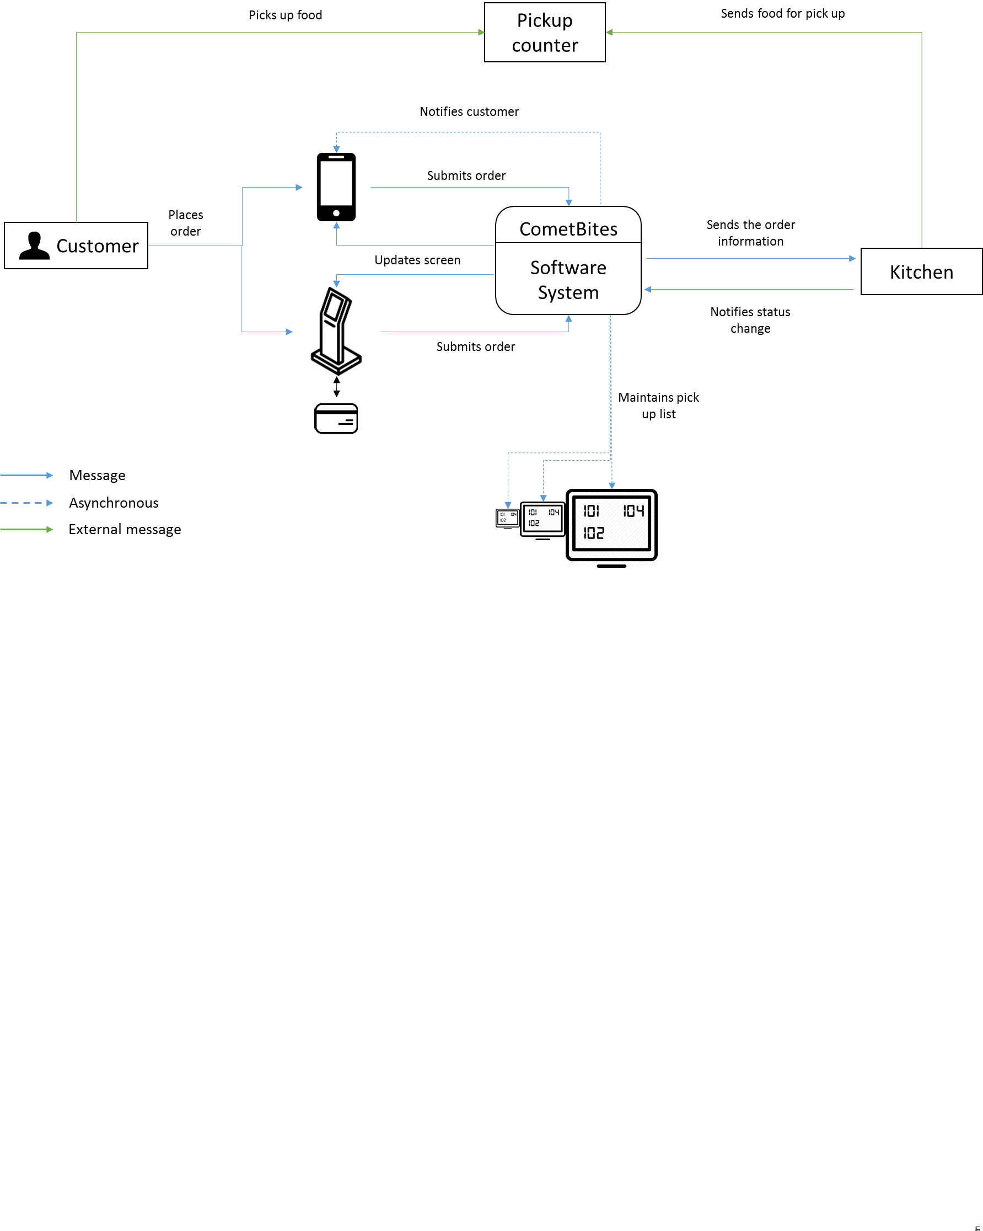

**Figure 1:** Software system context diagram.

# 5. Cost-Benefit Analysis

The benefits associated with this project are that more people will order food online as they will have an estimated waiting time so they won’t have to skip meals or wait endlessly. It will be beneficial for the UTD food department as the students will order more on-campus rather than shifting to off-campus restaurants.

Final costs and pricing for the software system will be dictated by the type and the number of devices to be used since the application is going to run on the user’s smartphone. A single full kiosk price goes from $100.00 up to $10,000.00 or more. A complete but economic setup which includes a touchscreen, CPU, software and the installation might reduce the price of a single kiosk to $4,338. Alternatives that include only the standing (that supports a tablet), a minimal setup, can reduce the price even further to an average of $100. Although economically attractive, this minimal setup is prone to cease functioning in a short term, since the device is going to be used by a large number of users in a daily basis.

For the prototype, firstly, smartphones will be used to run the application. Secondly, a tablet will be used. It can simulate the usage of a kiosk closely, and the effort required to adapt the software system to run on a kiosk afterwards is considerably low. With economics options of $25 to $100, the tablet is technically, economically, and in terms of usability the best option for the device prototype.

Also, candidate 2 is most effective (cost-wise) as it requires least cost for installation and/or development. In comparison to this, candidate 3 and 4 require maximum cost of installation. Hence, Candidate 1 was chosen as it contemplates both the online functionality and the ordering in person. In order to address the complete scenario, this is the most feasible option.

# 6. Evaluation of Technical Risk

The team is familiar with online apps and we have the expertise to carry on with the project, making all candidates feasible. There is one aspect that is important to note, which is the fact that, for candidates 1 and 3, although the technologies already exist, the team doesn’t have the expertise to operate and/or interact with the kiosk machine, which slightly increases the learning curve. This is not expected to have a high impact in the predicted project completion.

(UPDATE – after project risks)

# 7. Operational Impact

The operational feasibility includes the adaptability of the project in the existing environment. It includes the changes that the solution needs to make in the existing environment and what are the impact of those changes. First, there should be proper synchronization with the UTD system. This interaction requires permission from the UTD food and dining services department, which is already granted. Second, the ease of access and the flexibility offered by the software system is an important aspect because it needs to minimize the influence to the existing environment. The daily operations that are currently available should remain similar after the deployment of the solution.

Considering these aspects, candidate 2 would be the best option, since there are no drastic changes to the environment. However, other aspects must be taken into account, such as the amount of features provided to the users and a more complete set of benefits after project conclusion. Since candidate 1 is not limited to student users, it serves different kind of users as well. Hence, candidate 1 is selected because of this trade-off analysis.

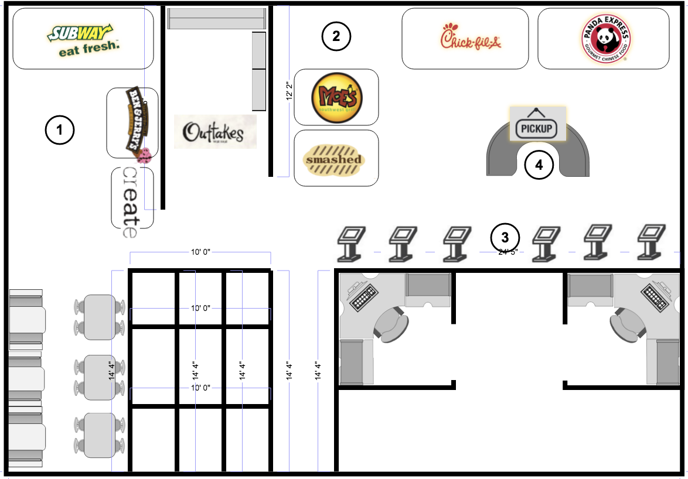

**Figure 2:** Dining environment after deployment of the software system.

Figure 2 illustrates the environment changes after the deployment of the solution. It is possible to identify two main locations where a customer can purchase food from[5]: Comet Café (area 1) and Student Union Food Court (area 2). Within these areas, there are mainly three restaurants that are affected by the long waiting lines problem. These are Subway, Chick-fil-A, and Panda Express. Note that due to space limitations, the kiosks will be placed in area 3. With the addition of the pickup process, the food joints will have to provide a pickup counter for the customers to pick up their orders. There are two locations where this counter can be placed. If the food joints agree to have a common location for their customers, the counter will be located at area 4. Since the food joints might want to handle their own orders separately, Figure 3 illustrates the alternative place for the pickup counters.

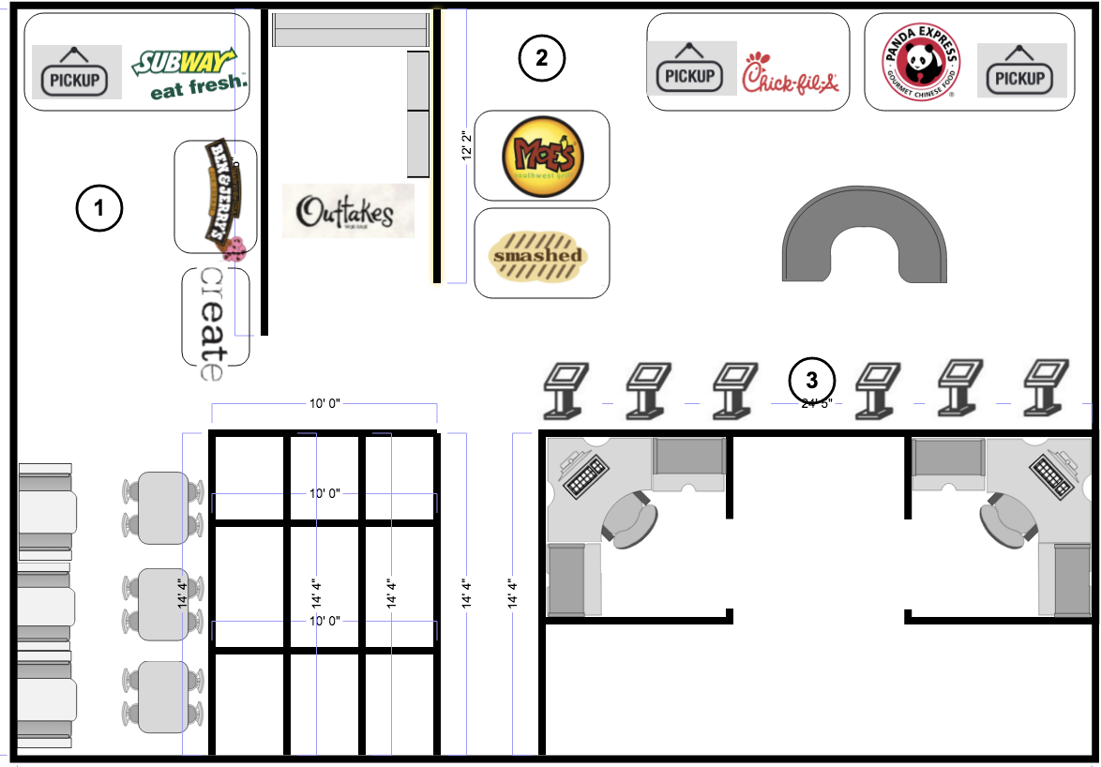

**Figure 3:** Alternative environment after deployment of the software system.

# 8. Legal Ramifications

In the case where additional staff members must be hired in order to make the software system function properly, this project is subjected to a legal regulation. Each food joint has a number of maximum staff members that can work simultaneously based on the food joint area. If that threshold is exceeded for any food joint, this project will be deemed infeasible for legal reasons.

According to the department, the software system is not affected by other legal ramifications. However, this project will follow an iterative development which will include multiple meetings that might change the requirements and/or bring some other legal aspects to light. Whenever there is such a change, the newly identified legal rules and regulations will be discussed with the respective department and will be updated in the next version.

# 9. Schedule Analysis

There is a strict time limitation for this project which is a major criterion in selection of the candidate. This project must be delivered on December 2nd. In order to accomplish this, the selected candidate must have a realistic schedule. It is possible to state that all candidates have realistic schedule with some degree of flexibility, so even though time constraint is a critical criterion, it is not decisive by its own.

One aspect that must be considered is the learning curve. As mentioned previously, some technologies are not within the team’s expertise. This will have an impact in the schedule. Last but not least, the amount of time available will dictate if the project is useful or not by the project completion date. Candidate 1 is the only alternative which will be useful as soon as the project is finished. Due to these factors, candidate 1 is the best option.

# Appendix A: Glossary

|  |  |
| --- | --- |
| **Term** | **Definition** |
| **UTD** | University of Texas at Dallas |
| **TBD** | To be defined |
| **POSF** | Point of Sale functionality |

1. http://www.tapingo.com/
2. https://play.google.com/store/apps/details?id=com.subway.mobile.subwayapp03&hl=en
3. https://play.google.com/store/apps/details?id=com.chickfila.cfaflagship&hl=en
4. https://play.google.com/store/apps/details?id=com.pandaexpress.app&hl=en
5. Dining: www.utdallas.edu/union/